# Business Problem To Be Solved

We created a database to solve the below challenges that we met in managing the volleyball team. If we just simply use file documents such as excel or spreadsheet to access the data, we may have the below challenges：

1. The data can be redundant, the same data may be input in different places several times. So the data may be redundant;
2. The data may be inconsistent. Updating data in one place cannot ensure the data in other places will be updated as well. So the data may be inconsistent;
3. The data may not be that accurate;
4. Hard to use the different excel files to do game analytics;
5. The wrong management of team order and the unreasonable resource may lead to the unfairness of the data allocation;
6. Hard to get enough data from player or match to improve the performance;
7. It is hard to collect all data for the historical analysis to facilitate decision making for every match.
8. Tickets are not managed in an efficient way. Scattered ticket records cause lost or duplicated tickets and no single source of truth.
9. Coach cannot access the data to analyze the match data, historical data to improve its strategy for future game;
10. Players cannot get enough useful and comprehensive data from match records.
11. It’s hard to record the internal revenue of the team;
12. It’s hard to demonstrate our team performance to the sponsors.
13. We are preventing mishandling of accessible seats. Accessible seats aren’t reserved or tracked, risking poor fan experience.
14. e-tickets aren’t consistently issued on payment; delivery failures go unnoticed.
15. No reliable way to see which orders are fully paid, partially paid (split tender), or unpaid

So we create database to realize the improvement in our previously mentioned objectives as below:

1. Player & Team Performance Tracking

2. Match Scheduling & Queue Management

3. Financial Management

4. Data Security & Role-Based Access

# Business Rule

1. For completed matches, to make analysis more accurate, it is necessary to record match data as detailed as possible without duplication.

2. For different matches, all data can be compared and analyzed.

3. For a specific team, the match sequence can be updated on time(in the queue).

4. For the two teams in a match, it is necessary to distinguish between the home team and the away team.

5. Each match must have only one referee.

6. A player can only belong to one team (analysis is based on the season; players cannot transfer to other teams after the season begins).

7. Every match our volleyball team participates in here all belongs to a tournament.

8. Our volleyball team participates in tournaments from time to time.

9. For any given event/time, a seat can be assigned to at most one ticket.

10. Every order must contain at least one ticket .

11. Each ticket must have a delivery method(e-ticket/physical).

12. Every venue must have greater than or equal to one section.

13. Refunds must use the same method as the original payment when possible (cash to cash, card to card).

14. Record includes the data of all matches in history such as matches, wins, losses for the game analysis.

# Key database design decision

Focusing on a few core architectural principles helped in the development of the schema for the database. Most of the major design decisions can be encapsulated around our first two key entities. One set of decisions relates to the Team entity, while the other pertains to the Match entity. These decisions cumulatively address the robustness of the design while meeting the key business needs.

For the Team entity, the main goal was to encapsulate it as a concise, definitive, and authoritative identity in the system. To maintain reference point status, we built Team to unify and control data so that any entity’s change involves information in a single repository. All other entities, like Player and Coach, connect to this Team identity. Additionally, we instituted a one-to-many relationship between Team and Player in line with the business rule that roster simplification is vital for operational needs.

Regarding the Match entity, the key decision was to position it as the operational hub that connects all event-related activities. This design allows the Match to unify various entities like Team, Venue, and Ticket, providing a complete view of each event. To accurately represent a real-world competition, we also modeled two specific relationships from Match to Team: one for the "Home Team" and one for the "Away Team". This approach clearly defines the roles of the participants and structurally enforces the rule that a match is a contest between two distinct teams.

# Entities & Relationships

| **No** | **Entity Name** | **Purpose** | **Related Entities** | **Cardinality** |
| --- | --- | --- | --- | --- |
| 1 | Team | Record team information. | Coach | One to one |
| Player | One to many |
| Tournament | Many to many |
| 2 | Player | Record the players' personal files. | Team | One to many |
| PLAYER_MATCH_STATS | One to many |
| 3 | Coach | Record coach information. | Team | One to one |
| 4 | Match | Record match information. | Tournament | One to many |
| Court | One to one |
| Match Summary | One to many |
| Tickets | One to many |
| 5 | Tournament | Organize competitions and rankings. | Match | One to many |
| Team_Ranking | One to many |
| Team | Many to many |
| 6 | Referee | Record referee information. | Match | One to many |
| 7 | Record | Record the details and results of each match. | Match | One to one |
| 8 | Play_match_stats entity | Records a player's statistics in a single game. | Player | One to many |
| 9 | QUEUE | Schedule matches with fixed time slots. | Match | One to many |
| Tournament | Many to many |
| 10 | Customer | Person buying tickets and owning orders | Order | One to Many |
| 11 | Order | A purchase transaction that groups tickets and total | Customer | Many to one |
| Ticket | One to Many |
| Payment | One to Many |
| 12 | Ticket | Records the ticket details like ticket type, status | Order | Many to One |
| Match | Many to One |
| 13 | Venue | records the physical location that hosts matches | Match | One to Many |
| Section | One to Many |
| 14 | Section | An area within a venue that contains seats. | Venue | Many to One |
| Seat | One to Many |
| 15 | Seat | An individual place within a section that may be assigned to a ticket | Section | Many to One |
| Ticket | Optional Many to Optional One |
| 16 | Payment | Records the charge,method of payment and the amount. | Order | Many to One |
| Refund | One to Many |
| 17 | Refund | Money returned from a specific payment | Payment | Many to One |
| 18 | Tournament Queue | Record the team rankings and status in a tournament | Tournament | Many to One |
| Team | Many to one |

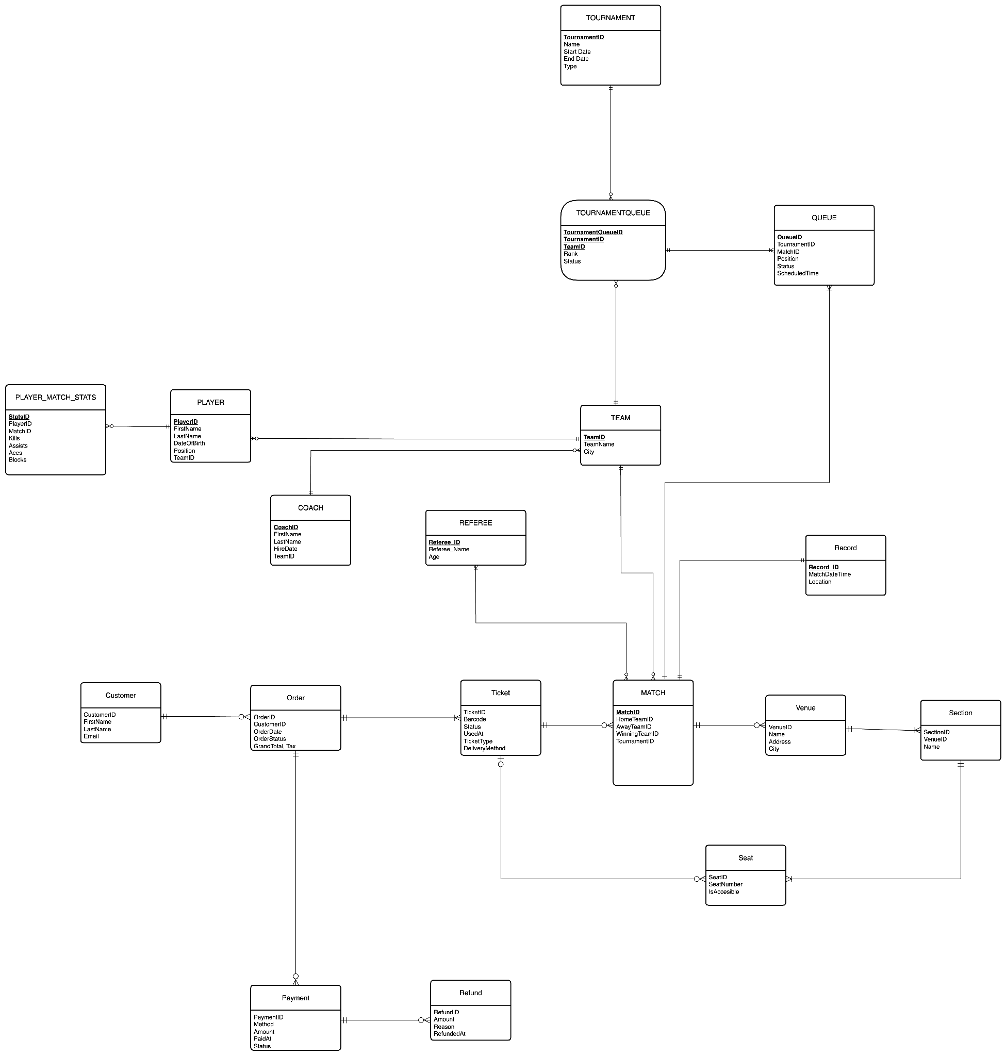

<https://app.diagrams.net/#G17CYBWxqSHq0ecyxe7W6E8PQqUzbS4-Dk#%7B%22pageId%22%3A%22CQReCo5fqBLi9tCP4P8s%22%7D>